**TRISHA’S PLANT SHOP**

**aglaonema**

**BLACK ESMERALDA** **5,500.00**

**LOTUS DELIGHT** **8,600.00**

**PINK MOONLIGHT** **7,300.00**

**Suksom jaipong** **2,500.00**

**philodendron**

**RED CONGO** **3,000.00**

**BLACK CARDINAL** **4,500.00**

**THAI CONSTELLATIONS** **9,700.00**

**Pink princess** **2,700.00**

**Aglaonema**

**Black esmeralda**

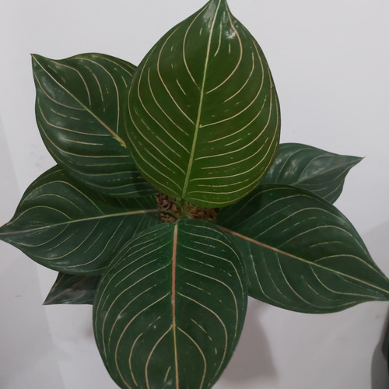

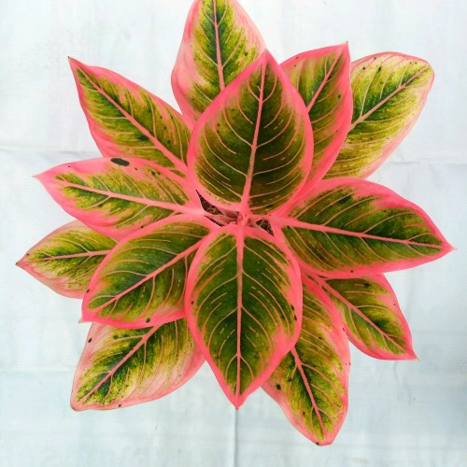**Lotus delight**

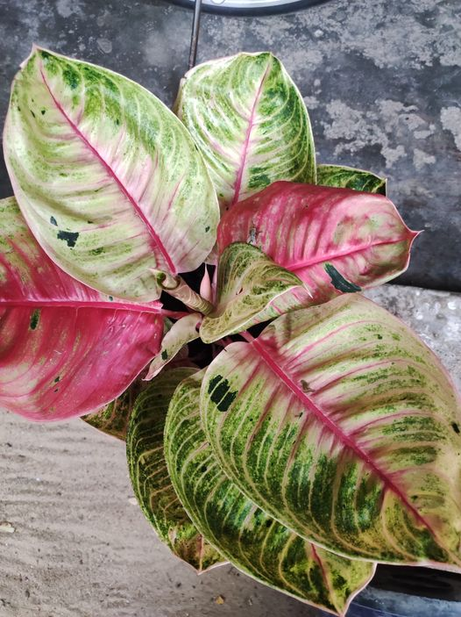

**Pink moonlight**

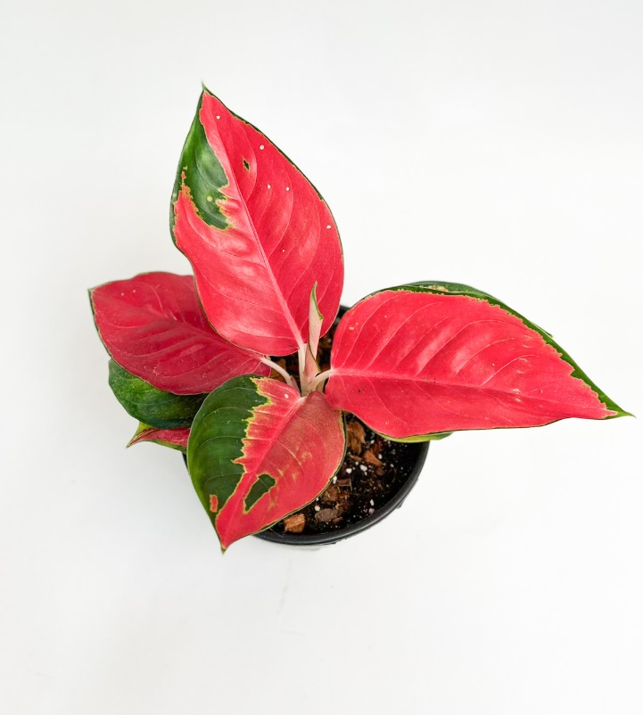

**Suksom jaipong**

**Philodendron**

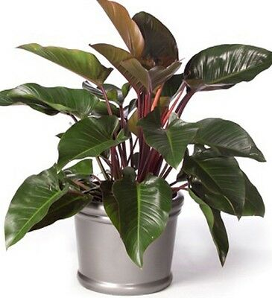 **Red congo**

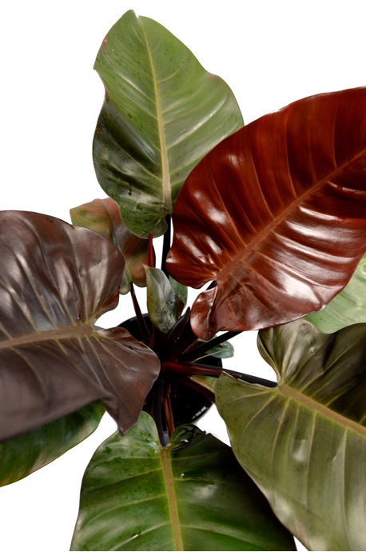 **Black cardinal**

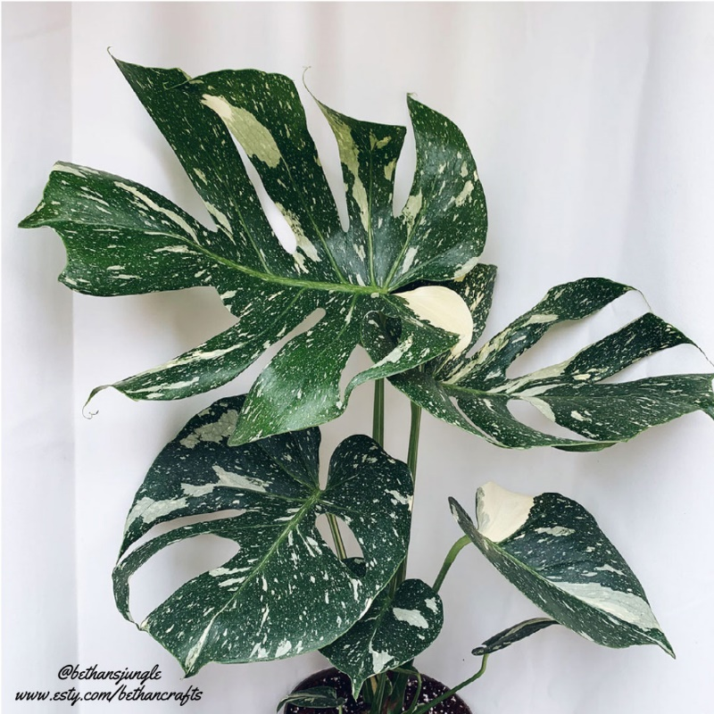

**Thai constellations**

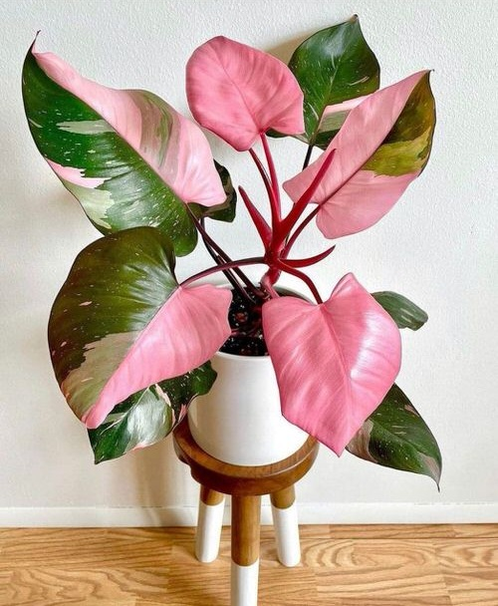

**Pink princess**

**back to top**