APPOINTMENT SCHEDULING OUTPUTS

1. CALENDLY CALENDAR

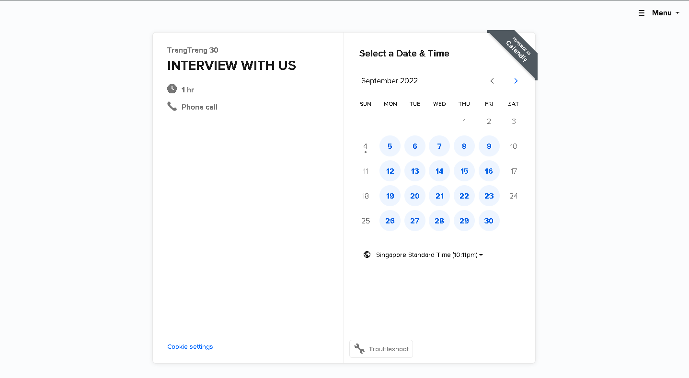

1. GOOGLE CALENDAR

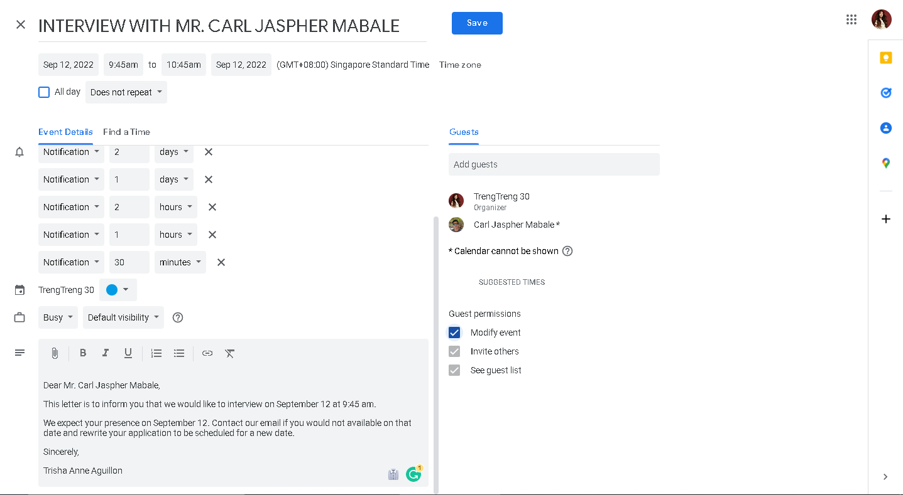

1. YOUCANBOOK.ME

